# EICC Awareness And Code of Conduct

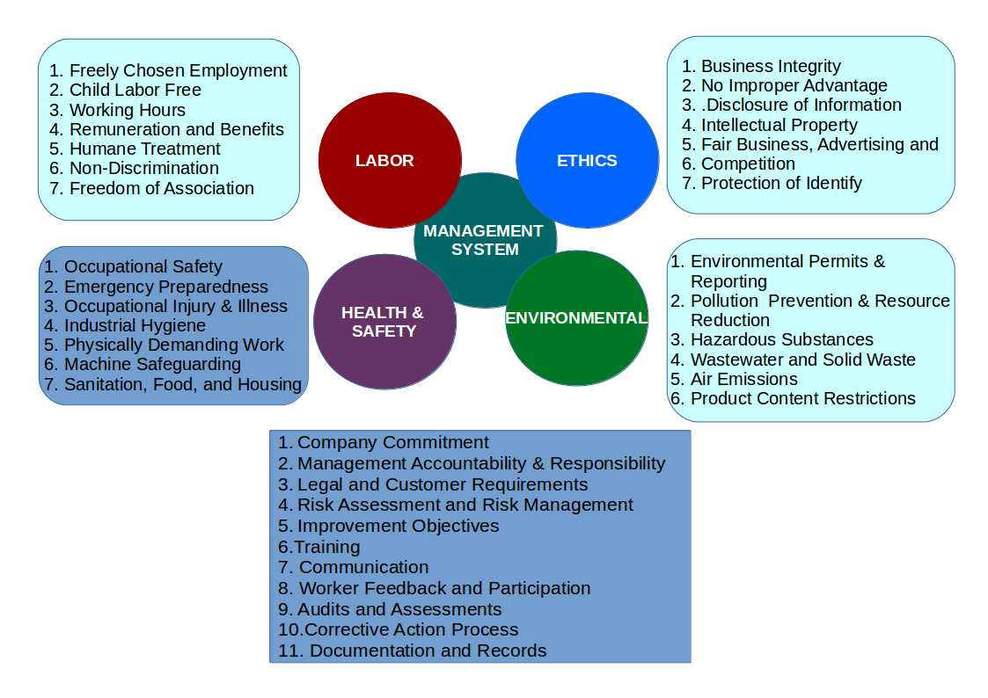



**ANS ASSOCIATES PVT. LTD.**